**Magnets, Superconductors and Cryostats September 2012**

**TE-MSC** **Technical Note 2012-xx**

[**main.author@cern.ch**](mailto:main.author@cern.ch)

EDMS Nr: XXX XXX

**Magnetic measurements of PS Booster orbit corrector type 8af (PXMCXADWAP)**

M. Buzio, P. Galbraith / TE Department

Keywords: magnetic measurement, harmonic coil, resistive air-cooled bending dipole, CTF3 magnets

Distribution:

TE-MSC scientific staff, F. Bordry

1. Introduction

Old name: TDV3 Version A [2]

Test conditions: 5 pre-cycles between ±10 A.

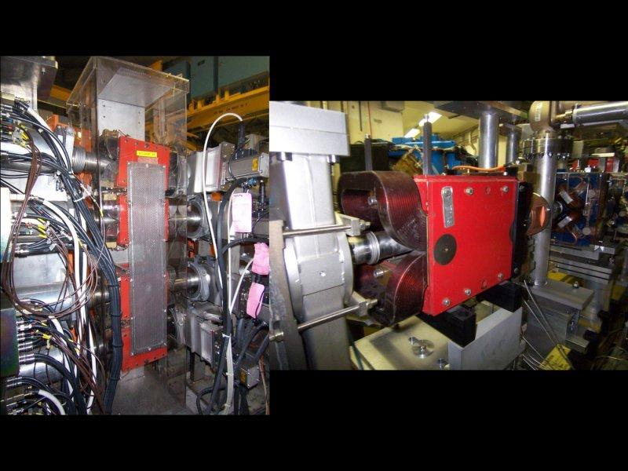

Fig. 1

1. Test results

Integral measurement over 2250 mm (3× rotating coil position), average of opposite current values to cancel out the influence of DC residual and/or background fields.

|  |  |  |
| --- | --- | --- |
| **I  (A)** | **∫Bd [mTm]** | **transfer function [mTm/A]** |
| ± 0.2 | 0.193 | 0.965 |
| ± 10 | 9.917 | 0.992 |

A detailed loadline of the integral field over the central 750 mm (1× rotating coil position) was done to evaluate nonlinearity and hysteresis (Fig. 2). Exclusion of the two extreme measuring coil positions leads to neglecting a part of the fringe field equivalent to 0.5% at 10 A. Correcting proportionally for this truncation error and computing a linear regression we find

Average (least squares) transfer function: 0.922 mTm/A

Regression offset: 0.009 mTm (0.1% of nominal)

Integrated BdL @ 8 A (nominal) 7.953 mTm

Integrated BdL @ 10.08 A (extrapolated) 10.00 mTm



Fig. 2 – Loadline over 750 mm (central coil position onily)

The regression offset can be interpreted as a combination of the remanent field trapped in the iron (which in principle could be further reduced by degaussing + always powering the magnet along the same limit hysteresis cycle) plus the background (which should be the remaining component after degaussing; also, this should depend on the placement and orientation of the magnet)



Fig. 3

The nonlinear part of the hysteresis curve is shown in Fig. 3. In the range considered the linearity of the magnet is very good, saturation being only about 0.02% at 10 A. The absolute width of the hysteresis loop is less than 0.03 mTm, which gives the envelop of the error that can be expected when the magnet is operated by varying the current at random with the ±10 A bounds. In relative terms, this is equivalent to an error of about 0.15% at 8 A and 13.8% at 0.2 A.

The hysteresis curve traced by the transfer function, which could be used to establish the current/field ratio to be used in operation, is shown in Fig. 4. The shape of the ramp-up branches is different from the shape of the ramp-down branches, because of the vertical offset due to the residual field in the BdL(I) hysteresis curve. Note that when the current crosses zero, the transfer function goes to infinity and changes sign.



Fig. 4 – The arrows indicate the orientation of each branch.

Integrated field harmonics @ ±0.2 A

b2 = -19.56 a2 = 2.50 [units @ 40.0 mm]

b3 = 13.23 a3 = -17.21 [units @ 40.0 mm]

b4 = 3.26 a4 = 11.37 [units @ 40.0 mm]

b5 = 29.96 a5 = 5.74 [units @ 40.0 mm]

b6 = -11.78 a6 = 5.59 [units @ 40.0 mm]

b7 = 23.53 a7 = 4.15 [units @ 40.0 mm]

b8 = -4.88 a8 = 0.25 [units @ 40.0 mm]

b9 = 0.69 a9 = 1.21 [units @ 40.0 mm]

b10 = -0.96 a10 = 5.24 [units @ 40.0 mm]

b11 = -5.97 a11 = 6.19 [units @ 40.0 mm]

b12 = -2.32 a12 = -7.85 [units @ 40.0 mm]

b13 = 5.75 a13 = -5.35 [units @ 40.0 mm]

b14 = 3.49 a14 = -5.34 [units @ 40.0 mm]

b15 = 4.89 a15 = 10.55 [units @ 40.0 mm]

Integrated field harmonics @ ±10 A

b2 = 0.63 a2 = -5.92 [units @ 40.0 mm]

b3 = 2.57 a3 = -10.88 [units @ 40.0 mm]

b4 = -4.09 a4 = 3.18 [units @ 40.0 mm]

b5 = 30.46 a5 = 1.33 [units @ 40.0 mm]

b6 = -6.91 a6 = 0.27 [units @ 40.0 mm]

b7 = 32.83 a7 = -0.48 [units @ 40.0 mm]

b8 = 0.16 a8 = 0.83 [units @ 40.0 mm]

b9 = 1.47 a9 = 0.80 [units @ 40.0 mm]

b10 = 0.17 a10 = 0.92 [units @ 40.0 mm]

b11 = -1.69 a11 = 0.65 [units @ 40.0 mm]

b12 = -0.37 a12 = 0.24 [units @ 40.0 mm]

b13 = 0.92 a13 = 0.03 [units @ 40.0 mm]

b14 = -0.30 a14 = -0.13 [units @ 40.0 mm]

b15 = -1.22 a15 = 0.62 [units @ 40.0 mm]

References

[1] NORMA DB link: <http://norma-db.web.cern.ch/cern_norma/magdesign/idcard/?id=224>

[2] M. Chanel, “SPECIFICATION ET MESURE MAGNETIQUE DES DIPOLES TYPE 8af, TDV, 8bf”, 1976, [EDMS 1021521](https://edms.cern.ch/file/1021521/1/1021521_5.pdf)