DIRAC collaborations status report
June 2017.
I. Long-lived states of π⁺π⁻ atoms.
1. The published DIRAC experimental result on observation of 436±61 long-lived π⁺π⁻ atoms will be used for the first measurement of the long-lived π⁺π⁻ atom lifetime. All data are reprocessed using improved setup geometry, detector response and two types of analysis. The corresponding publication is planned before October of 2017.
2. A possibility of evaluation of limit for the π⁺π⁻ atom Lamb shift, using existing data, will be studied in 2017.

II. Status of K⁺π⁻ and K⁻π⁺ atoms investigation.
1. The paper “Observation of K⁺π⁻ and K⁻π⁺ atoms” was published in Physical Review Letter 117, 112001(2016) (see also CERN preprint CERN-EP-2016-128; arXiv:1605.06103).
2. From analysis of all available data the Kπ atom lifetime and Kπ scattering length combination $a_{0}^{-}=\frac{1}{3}(a_{1/3}-a_{2/3})$ were evaluated:
- One-dimensional analysis over Q: $a_{0}^{-}={0.072}_{-0.020}^{+0.031}$, the average relative error is 35%.
- Two-dimensional analysis over Q_{L}, Q_{T} : $a_{0}^{-}={0.086}_{-0.024}^{+0.044}$, the average relative error is 40%.
The previous published result of DIRAC (Physics Letters B 735 (2014) 288) provided the average relative error equal 60%(analysis on Q_{L}, Q_{T}): $a_{0}^{-}={0.11}_{-0.04}^{+0.09}$.
The $a_{0}^{-}$ values evaluated in LQCD (5% precision), ChPT (about 10% precision) and with Roy-Steiner equations (6% precision) are in agreement with above values.
The dedicated paper (28 pages) was submitted as CERN preprint in June 13 of 2017.

III. π⁺π⁻ atom lifetime measurement.
1. In the past the π⁺π⁻ pairs from 2008-2010 data were used as calibration process for the πK pairs analysis. Preliminary results on the short-lived atom lifetime measurement based on all available 2008-2010 data now are ready and presented below (see Fig. 1 and 2).
The average probability of π⁺π⁻ atom breakup for the Ni targets of 98 mkm thickness (RUN 2008) and 109 mkm.(RUNS 2009-2010) was evaluated as P_{br}= 0.474 ± 0.01. It coincides with the value P_{br}= 0.46 ± 0.013 obtained for the 98mkm target and published in 2011.
In the final data analysis the new measurements of multiple scattering will be include. The dedicated paper will be published before the June of 2018.

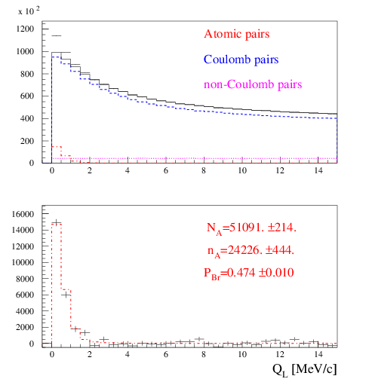
Fig.1. Distribution over |Q_{L}| for events, selected with criterion Q_{T} < 4 MeV/c. Fractions of atomic, Coulomb and non-Coulomb pairs were obtained by fitting the distribution over (|Q_{L}|,Q_{T}) with criteria: |Q_{L}|<15 MeV/c, Q_{T} < 4 MeV/c. N_{A}, n_{A} and P_{br}. are the number of produced atoms, detected atomic pairs and probability of the atoms breaking in the target respectively.

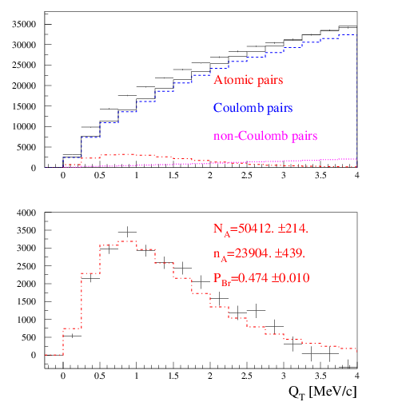
Fig.2. Distribution over Q_{T} of events, selected with criterion |Q_{L}| < 2 MeV/c. Fractions of atomic, Coulomb and non-Coulomb pairs were obtained by fitting the distribution over (|Q_{L}|,Q_{T}) with criteria: |Q_{L}|<15 MeV/c, Q_{T} < 4 MeV/c. N_{A}, n_{A} and P_{br}. are the number of produced atoms, detected atomic pairs and probability of the atoms breaking in the target respectively.

2. The current value of systematical error in the π⁺π⁻ atom lifetime measurement is equal to statistical uncertainty. The main part of systematical error arises due to an uncertainty in the multiple scattering in the Ni target. To reduce this error, we continue experimental study of the multiple scattering of our targets: Ni: 50, 109 and 150 microns; Be: 100 and 2000 microns; Pt: 2 and 30 microns and Ti: 250 microns. For Be (2000 microns) and Ni (109 microns) the difference between theoretical and experimental r.m.s. is 0.4% and 0.8% accordingly. The r.m.s. values were calculated in the interval of ±2σ. The achieved precision of multiple scattering investigation is better on one order of magnitude than in the previous experiments. The dedicated paper will be published in 2018.
IV. K⁺K⁻ pair analysis.
1. Investigation of K⁺K⁻ pairs was performed in 2017 with improved procedure of the particles identification using time-of-flight technique and the data from heavy gas Cherenkov counters. At present time, the only data of RUN 2010 were processed. After background subtraction, the full laboratory momentum spectrum of K⁺K⁻ pairs was evaluated (see Fig. 3).
Fig.3. Distribution of K⁺K⁻ pairs in the RUN 2010 over full pair momentum in laboratory system. Number of pairs is 93000. Expected total number of K⁺K⁻ pairs in 2008-2010 is around 230000.
The second step is a search for a signal from the K⁺K⁻ Coulomb pairs. For the analysis were selected pairs with the low laboratory momentum 2.6 <P <4.0 GeV/c and with the high laboratory momentum 6 < P <10 GeV/c because in this two intervals the level of the background is relatively small (see the errors on Fig. 3) The time-of-flight distribution for the low momentum interval show on the Fig.4. The proton-antiproton pairs are absent as for them the ΔT is less than -6 ns. For ΔT less than -0.5ns. the number of K⁺K⁻ and π⁺π⁻ pairs are comparable. The time-of-flight distribution for the high momentum interval shown on Fig.5. For the pions with this momentum the efficiency of the Cherenkov’s counter is near 0.95. Therefore the suppression of π⁺π⁻ pairs is high and this background is negligible. For the low and high momentum intervals, the selecting procedure choose the ranges over ΔT with contribution of K⁺K⁻ pairs more than 50% of the total statistics. The admixture of π⁺π⁻ pairs in the low momentum interval and admixture of proton-antiproton in the high momentum interval were defined using events distributions over ΔT.
The distributions of the selected events on Q_{L} for the three values of Q_{T} for both intervals on P to show on the Fig.6. The admixtures of π⁺π⁻ and proton-antiproton pairs calculated as K⁺K⁻ pairs were subtracted. Nevertheless the background of π⁺π⁻ pairs is existing. Therfore the experimental distributions of selected events were fitting by the sum of simulated distributions of K⁺K⁻ pairs and the experimental distributions of experimental π⁺π⁻ pairs processed with kaon masses. In the distributions of K⁺K⁻ pairs there is a clear signature of the Coulomb enhancement. The number of produced K⁺K⁻ atoms will be evaluated from the number of K⁺K⁻ Coulomb pairs with small relative momentum in their center of mass. In the RUN 2010 were identified 2180 ± 200 K⁺K⁻ pairs. The total number of K⁺K⁻ pairs after processing of all statistics will be about 5000 events.
2. Simulation of K⁺K⁻ atoms yield and spectrum for proton momentum 24 GeV/c and 450 GeV/c using CERN version of FRITIOF generator is finished:
DIRAC-NOTE-2016-07 “The estimation of production rates of K⁺K⁻ and proton-antiproton atoms in proton-nucleus interactions at 450 GeV/c,” O. Gortchakov [JINR], L. Nemenov [JINR]
3. Investigation results will be published in 2018.

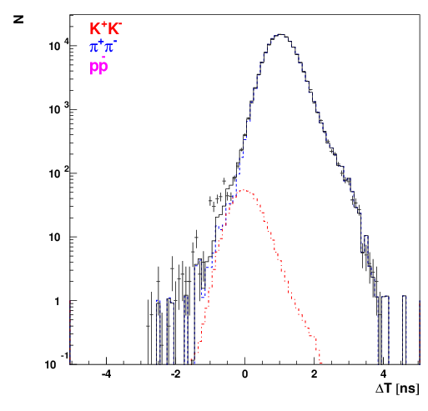
Fig.4. Time of flight distribution for the low momentum interval.

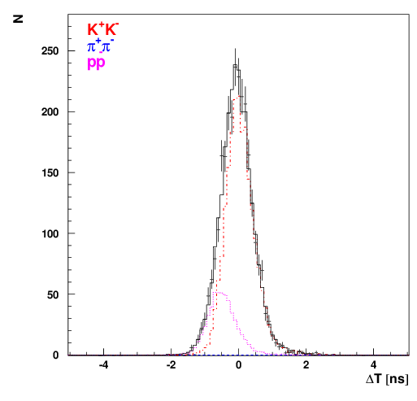
Fig.5. Time of flight distribution for the high momentum interval.
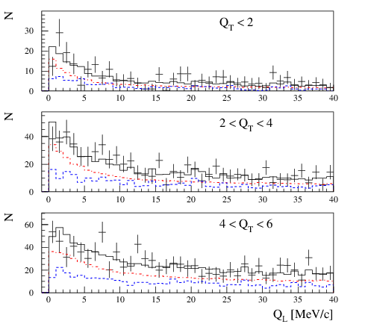
Fig.6. Experimental distributions of events selected. Events are fitted by simulated distribution of K⁺K⁻ pairs (red) and experimental distribution of pure π⁺π⁻ (blue) processed with kaon masses. The integral number of K⁺K⁻ pairs is 2180 ± 200, the number of π⁺π⁻ pairs is 1340 ± 200
V. Proton-antiproton pair analysis
In 2018 DIRAC will perform a search for proton-antiproton Coulomb pairs and thus proton-antiproton atoms with the same strategy as in the K⁺K⁻ case (see section IV).
Investigation results will be published in 2019.

VI. Investigation of K⁺π⁻, K⁻π⁺ and π⁺π⁻ atoms production in
p-nucleus interaction at proton momentum 24 GeV/c and 450 GeV/c
1.The paper “The estimation of production rates of K⁺π–, K–π⁺ and π⁺π– atoms in proton-nucleus Interactions at 450GeV/c” published in the J.Phys. G: Nucl. Phys. 43 (2016) 095004.
The dedicated analysis has shown that, taking into account the yields of dimesoatoms at 450 GeV/c $(θ_{lab}=4°)$ and the working conditions at SPS, the number of π⁺π⁻, K⁺π– and K–π⁺ atoms generated per time unit will be 122, 5311 and 245 times higher than in the DIRAC experiment. The significant increase in the K⁺π– and K–π⁺ atoms statistics will allow to measure $|a_{1/3}-a_{2/3}|$ with precision of 5% and to check our understanding of the chiral ${SU(3)}_{L}×{SU(3)}_{R}$ symmetry breaking of QCD. The setup upgrade and geometry modification will allow to improve this precision significantly.
In the DIRAC experiment there were observed 436 ± 57_{stat} ± 23_{syst} long-lived π⁺π⁻ atoms with the lifetime s. The higher energy of proton beam and the simple change of the experiment scheme open a new possibility for the investigation of the long-lived π⁺π⁻ atoms. In the new scheme the number of π⁺π⁻ atoms, generated per time unit will be more than 12 times higher than in DIRAC experiment. The background will be also significantly decreased . The statistics increasing and significant background suppression open a possibility to use the resonance method for measurement of only one parameter, the Lamb shift, and to evaluate the combination of the ππ scattering lengths $2a_{0}+a_{2}$. This measurement uses only the Lorenz transformation and quantum mechanics.

VII. Preparation of a Letter of Intent and the activity in PBC Committee.
The report about the investigation of dimesoatoms at SPS energy was presented at the workshop “Physics Beyond Collaiders” in September 2016 and the work with PBC Commettee is continuing during 2017: the dedicated reports were presented on the Beam Working Group in February 2017 and on the QCD working group in March 2017. The one of the main requirement of the Beam Working Group is decreasing of the future setup width up to 6 meters. At present time, we are studying two possible setup schemes. In the first scheme detectors with the high coordinate precision and a weaker magnetic field is considered. This scheme with the width less than 6 meters is ready and will be presented on the PBC Committee in autumn 2017. In the second scheme, usage of two magnet placed one by one is considered. The first magnet will deflect particles and the second one will return them back forming the beam of secondary particles with the small divergence in horizontal plane. The results of thies investigations will be ready in October 2017.

VIII. Instrumental publication
The paper “Updated DIRAC spectrometer at CERN PS for the investigation of ππ and Kπ atoms” was published: Nucl. Instr. Meth. A839 (2016) 52.

IX. Measurement of K⁺π⁻, K⁻π⁺ and π⁺π⁻ atoms production cross sections in proton interaction with Be, Ni and Pt nuclei basing of 2007-2012 experimental data will be done in 2019.
Dedicated measurements of the proton flux and the dead time in electronics and DAQ were done for these purposes. Estimation of systematic biases in our cross sections can be done basing on extrapolation of single particle production cross sections available for 32 GeV/c protons. The dedicated paper will be published in 2019.
G. The report about the investigation of dimesoatoms at SPS energy was presented at the workshop “Physics Beyond Collaiders” in September 2016 and the work with PBC Commettee is continuing during 2017 : the dedicated reports were presented on the Beam Working Group in February 2017 and on the QCD working group in March 2017

