DIRAC collaboration status report
SPSC, October 2017.

I. Long-lived states of π⁺π⁻ atoms.
1. The published DIRAC experimental result on the observation of long-lived π⁺π⁻ atoms is used for the first measurement of the long-lived π⁺π⁻ atom lifetime. All data are reprocessed using improved procedure of analysis. The preliminary values of the lifetime will be presented. The draft of corresponding paper is ready and will be send for publication before the end of 2017.
2. A possibility of evaluation of a limit for the π⁺π⁻ atom Lamb shift, using existing data, will be studied in 2018.

II. Status of K⁺π⁻ and K⁻π⁺ atoms investigation.
The paper “Measurement of the πK atom lifetime and the πK scattering length” published as a CERN preprint (CERN-EP-2017-137) and accepted for the publication in Phys. Rev.

III. The short-lived π⁺π⁻ atom lifetime measurement.
1. In the past, the π⁺π⁻ pairs from 2008-2010 data were used as calibration process for the πK pairs analysis. Preliminary results on the short-lived atom lifetime measurement based on all available 2008-2010 data are now ready and presented below (see Fig. 1 and 2).
The average probability of π⁺π⁻ atom breakup for the Ni targets of 98 µm thickness (RUN 2008) and 109 µm (RUNS 2009-2010) was evaluated as Pbr= 0.474 ± 0.01. It is in agreement with the value Pbr= 0.46 ± 0.013 obtained for the 98 µm target and published in 2011. In the final data analysis, the new measurements of multiple scattering will be included. The dedicated paper will be ready before June of 2018.
2. The current value of systematical error in the π⁺π⁻ atom lifetime measurement is equal to the statistical uncertainty. The main part of the systematical error arises due to an uncertainty in the multiple scattering in the Ni target. To reduce this error, we did an experimental study of the multiple scattering of our targets: Ni: 50, 109 and 150 microns; Be: 100 and 2000 microns; Pt: 2 and 30 microns and Ti: 250 microns. For Be (2000 microns), Ni (109 microns) the difference between theoretical and experimental r.m.s. is 0.4% and 0.8% accordingly. The r.m.s. values were calculated in the interval of ±2σ. The achieved precision of multiple scattering investigation is better by one order of magnitude than in the previous experiments. The dedicated paper will be published in 2018.

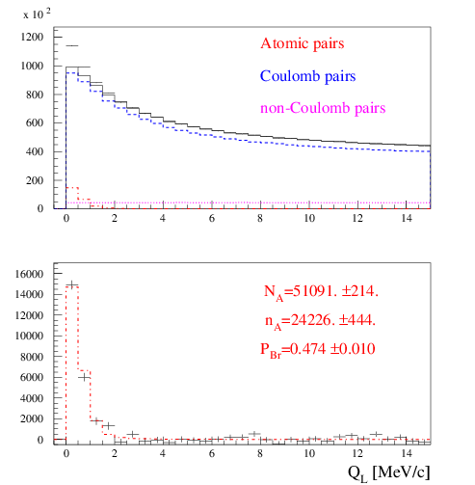
Fig.1. Distribution over |QL| for events, selected with criterion QT < 4 MeV/c. Fractions of atomic, Coulomb and non-Coulomb pairs were obtained by fitting the distribution over (|QL|,QT) with criteria: |QL|< 15 MeV/c, QT < 4 MeV/c. NA, nA and Pbr. are the number of produced atoms, detected atomic pairs and probability of the atoms breaking in the target respectively.
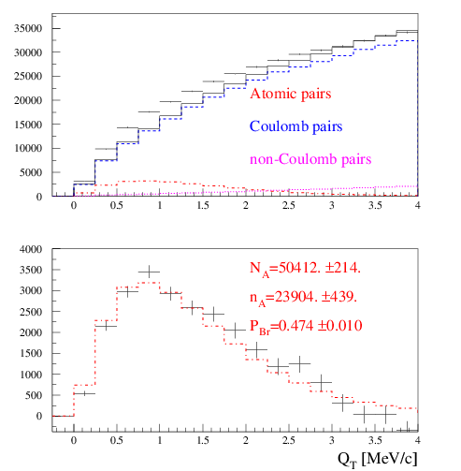
Fig.2. Distribution over QT of events, selected with criterion |QL| < 2 MeV/c. Fractions of atomic, Coulomb and non-Coulomb pairs were obtained by fitting the distribution over (|QL|,QT) with criteria: |QL|<15 MeV/c, QT < 4 MeV/c. NA, nA and Pbr. are the number of produced atoms, detected atomic pairs and probability of the atoms breaking in the target respectively.

IV. K⁺K⁻ pair analysis.

1. In 2017 the investigation of K⁺K– pairs was performed with an improved procedure of the particles identification using time-of-flight technique and the data from heavy gas Cherenkov counters. At present time, only the data of RUN 2010 were processed. After background subtraction, the full laboratory momentum spectrum of K⁺K– pairs was evaluated (see Fig. 3).
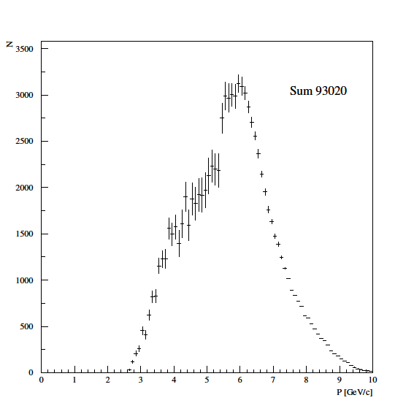
Fig.3. Distribution of K⁺K– pairs in the RUN 2010 over the full pair momentum in laboratory system. The number of pairs is 93000. The expected total number of K⁺K– pairs in 2008-2010 is around 230000.
The second step is a search for a signal from the K⁺K– Coulomb pairs. For the analysis we selected pairs with the low laboratory momentum 2.6 <P <4.0 GeV/c and with the high laboratory momentum 6 < P <10 GeV/c because in these two intervals the level of the background is relatively small (see the errors on Fig. 3). The time-of-flight distribution for the low momentum interval is shown in the Fig.4. The proton-antiproton pairs are absent as for them the ΔT is less than -6ns, where ΔT is average of the time-of-flight from X-plane of fiber detector to the vertical hodoscope for positive and negative particles of the pair. For ΔT less than -0.5ns the number of K⁺K– and π⁺π⁻ pairs are comparable. The time-of-flight distribution for the high momentum interval shown on Fig.5. For the pions with this momentum the efficiency of the Cherenkov counter is near 0.95. Therefore the suppression of π⁺π⁻ pairs is high and this background is negligible. For the low and high momentum intervals, the selection procedure chooses the ranges over ΔT with contribution of K⁺K– pairs more than 50% of the total statistics. The admixture of π⁺π⁻ pairs in the low momentum interval and admixture of proton-antiproton in the high momentum interval were estimated using events distributions over ΔT.
The distributions of the selected events in QL for the three values of QT for both intervals on P is shown in Fig.6. The admixtures of π⁺π⁻ and proton-antiproton pairs calculated as K⁺K– pairs were subtracted. Nevertheless, the background of π⁺π⁻ pairs is existing. Therefore the experimental distributions of selected events were fitted by the sum of simulated distributions of K⁺K– pairs and the distributions of experimental π⁺π⁻ pairs processed with kaon masses. In the distributions of K⁺K– pairs there is a clear signature of the Coulomb enhancement. In the RUN 2010 were identified 2180 ± 200 K⁺K– pairs with QT less than 6 MeV/c. The total number of K⁺K– pairs with QT less than 6 MeV/c after processing of all statistics will be about 5000 events.
The observed number of K⁺K– Coulomb pairs with small relative momentum will allow us to evaluate for the first time the number of K⁺K– atoms produced at same time.
2. The simulation of K⁺K– atoms yield and spectrum for proton momentum 24 GeV/c and 450 GeV/c using CERN version of FRITIOF generator is finished: DIRAC-NOTE-2016-07 “The estimation of production rates of K⁺K– and proton-antiproton atoms in proton-nucleus interactions at 450 GeV/c,”
3. Results of K⁺K– pairs investigation will be finished and published in 2018.

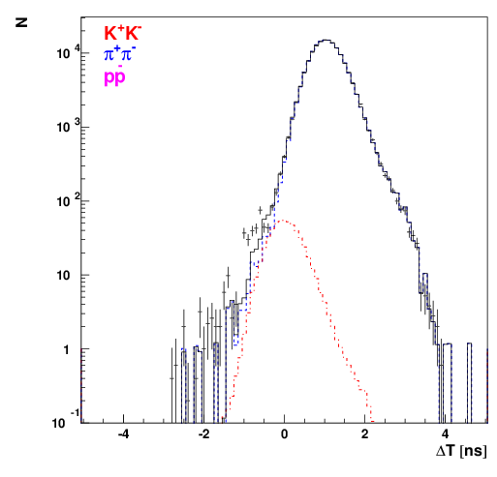
Fig.4. Time of flight distribution for the low momentum interval.

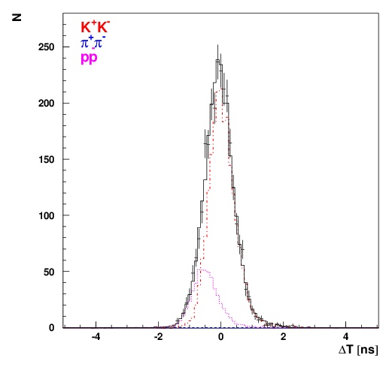
Fig.5. Time of flight distribution for the high momentum interval.

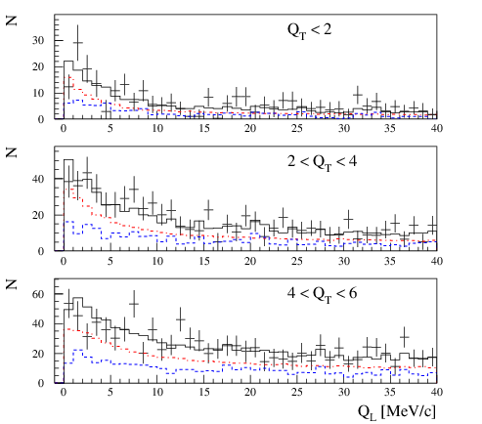
Fig.6. Experimental distributions of events selected. Events are fitted by the simulated distribution of K⁺K– pairs (red) and experimental distribution of pure π⁺π– (blue) processed with kaon masses. The number of K⁺K– pairs is 2180 ± 200, the number of π⁺π– pairs is 1340 ± 200

V. Proton-antiproton pair analysis
In 2018, DIRAC will perform a search for proton-antiproton Coulomb pairs and proton- antiproton atoms will be studied with the same strategy as in the K⁺K– case (see section IV). Investigation results will be published in 2019.

VI. Coulomb correlations as a possible new physical method to investigate the particles production region in the coordinate space.
The shape of Coulomb correlation curve for K⁺K– and proton-antiproton pairs is expected to be much sensitive to size of particle production region compared to the case of π⁺π– pairs. Thus, detailed study of this shape could open a possibility to evaluate the size of production region for such pairs. The investigation is planned for 2018.

VII. Investigation of K⁺π⁻, K⁻π⁺ and π⁺π⁻ atoms production in p-nucleus interaction at proton momentum 24 GeV/c and 450 GeV/c
1. The paper “The estimation of production rates of K⁺π–, K–π⁺ and π⁺π– atoms in proton-nucleus Interactions at 450GeV/c” published in the J.Phys. G: Nucl. Phys. 43 (2016) 095004.
The dedicated analysis has shown that, taking into account the yields of dimesoatoms at 450 GeV/c $(θ_{lab}=4°)$ and the working conditions at SPS, the number of π⁺π⁻, K⁺π⁻ and K–π⁺ atoms generated per time unit will be 12±2, 53±11 and 24±5 times higher than in the DIRAC experiment. The significant increase in the K⁺π⁻ and K–π⁺ atoms statistics will allow to measure $|a_{1/2}-a_{3/2}|$ with precision of 5% and to check our understanding of the chiral ${SU(3)}_{L}×{SU(3)}_{R}$ symmetry breaking of QCD. The setup upgrade and geometry modification will allow one to improve this precision significantly.
In the DIRAC experiment there were observed 436 ± 57stat ± 23syst long-lived π⁺π⁻ atoms with the lifetime s. The higher energy of proton beam and the simple change of the experiment scheme open a new possibility for the investigation of the long-lived π⁺π⁻ atoms. In the new scheme the number of π⁺π⁻ atoms, generated per time unit will be more than 12 times higher than in DIRAC experiment. The background will be also significantly decreased. The statistics increase and the significant background suppression open a possibility to use the resonance method for measurement of only one parameter, the Lamb shift, and to evaluate the combination of the ππ scattering lengths $2a_{0}+a_{2}$. This measurement uses only the Lorenz transformation and quantum mechanics.

VIII. Preparation of a Letter of Intent and the activity in PBC Committee.
The report about the investigation of dimesoatoms at SPS energy was presented at the workshop “Physics Beyond Colliders” in September 2016 and the work with PBC Committee is continuing during 2017: the dedicated reports were presented at the Beam Working Group in February 2017 and at the QCD working group in March 2017. One of the main requirements of the Beam Working Group is decreasing of the future setup width down to 6 meters. At present time, we are studying two possible setup schemes. In the first scheme, detectors with the high coordinate precision and a weaker magnetic field are considered. This scheme with the width less than 6 meters is ready and will be presented on the PBC Committee in November 2017. In the second scheme, usage of two magnets placed one after one is considered. The first magnet will deflect particles and the second one will return them back forming the beam of secondary particles with the small divergence in horizontal plane.

IX. Measurement of K⁺π⁻, K⁻π⁺ and π⁺π⁻ atoms production cross sections in proton interaction with Be, Ni and Pt nuclei basing of 2007-2012 experimental data will be done in 2019.
Dedicated measurements of the proton flux and the dead time in electronics and DAQ were done for these purposes. Estimation of systematic biases in our cross sections can be done on the basis of the extrapolation of single particle production cross sections available for 32 GeV/c protons. The dedicated paper will be published in 2019.

